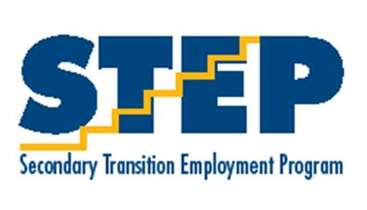
Out to Work
Upcoming Activities
Wednesday, Oct. 3rd- Healthiest State Walk 9:00 and 12:30
Thursday, Oct. 4th- Job Fair at Capital Square
Thursday, Oct. 18th- STEP Conferences 3:30-6:00 pm
Thursday, Oct. 25th and Friday, Oct. 26th- No School (Prof. Dev.)
October 30th- Volunteer Day

  - September 2018

STEP Newsletter
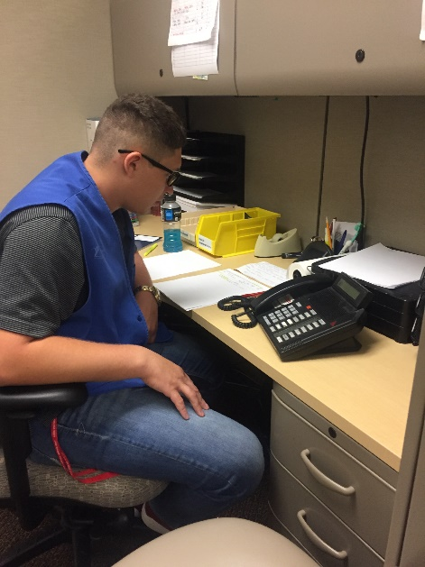

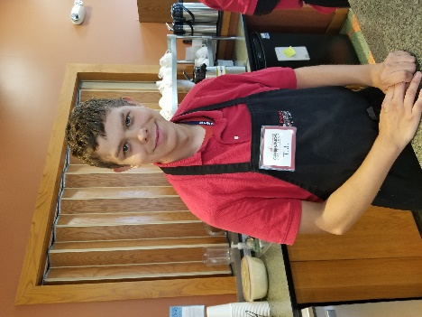
After Labor Day we started placing students in non-paid work experiences. Students are matched to a job site based on work interest inventories. Job site rotations typically last for 6-8 weeks. Students usually go to work sites in the morning and then come to afternoon class, or they start at Central Campus for class and then go to work sites in the afternoon. So far we have students placed at the VA Hospital, Plymouth 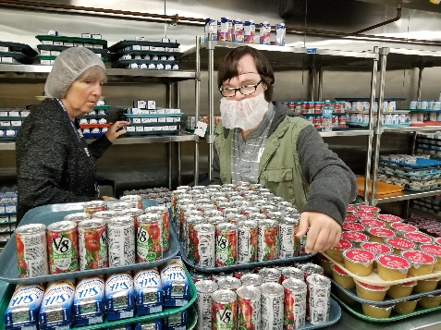
Grounds, DMACC, Jesse Taylor Preschool, and the DNR. Soon we will have workers at Habitat for Humanity, Wesley Acres, DMARC, Fareway, and Animal Life Line.

WoodLand Cemetary
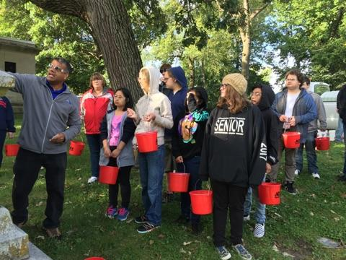
Service Learning

For this month’s service learning project we partnered with the Des Moines Park and Recreation Department. We participated in their memorial restoration project at Woodland Cemetery. Woodland Cemetery is a historical landmark and we got to help preserve it. Over the years, dirt, lichens, and mildew have deposited on the stones. Des Moines Park and Rec staff provided all of the supplies and trained our teams to clean and restore memorial stones.
We were really impressed with our students work on this project. It was kind of a dirty job with lots of detailed steps, but they did a great job!
If students like working outdoors, Des Moines Parks and Recreation is always looking for good volunteers. Information can be found on their website at www.dmgov.org/Departments/Parks/Pages/Volunteer.aspx

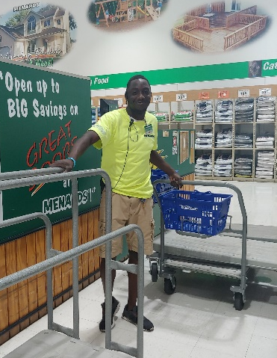

September Employees of the Month
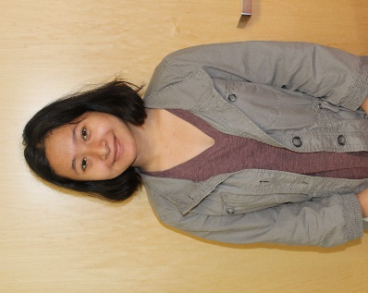
Celebrations!
Congratulations to Jamarcus and Htoo. They were both nominated for our first STEP Employees of the Month for the 2018-19 school year.
Jamarcus is a third year STEP student. He got a job at Marshalls his first year and maintained that for over two years. After moving Jamarcus decided to apply for a job closer to his new home. He was hired as lot attendant at Menards. Jamarcus has maintained this job since March. His supervisors report that he is a great worker. They can count on him to be at work and he even picks up extra shifts when they are short help. Jamarcus has a positive attitude and he loves his job.

Htoo is a first year STEP student from Roosevelt. Htoo is doing a work experience at the VA Hospital. Htoo has proven herself to be responsible and dependable. She always follows through and gets tasks done. She has a positive attitude and is willing to try new things. We are so glad she is part of our STEP family!

transition curriculum
Service Learning

During the month of September we continued to finish up our STEP assessments for the new year. We also started using our new NEXTUP curriculum. NEXTUP is a new curriculum that focuses on developing employment and life skills.
In September students participated in units on Working While in School, Setting Employment and Personal Goals, and Identifying and Understanding Strengths and Weaknesses. We learned about the differences in competitive employment, work experience, and volunteer work. We discussed the role of job coaches. We talked about SMART goals and practiced writing employment and personal goals. Each student also identified strengths and weaknesses and began talking about them.

Wednesday Skill Building Groups

Our Wednesday Skill Building Groups are off to a great start. The cooking group has planned and prepared appetizers, breakfast and a chili bar. The DART and shopping groups have planned and carried out routes to 22nd Street in WDM, Merle Hay Mall, and Hy Vee. While on their outings they have completed scavenger hunts to become familiar with the stores and they have worked on comparison pricing. The Permit Practice group has been studying for the learner’s permit exam. They have used various methods for learning information such as reading sections of the manual, learning games, and the online practice tests. Next week they will be going to the DOT to take the permit test.

October NEXT UP Weekly Topics

Week 1: Creating an Employment Portfolio, Application, and Resume
Week 2: Using Traditional and Social Network in the Employment Search
Week 3: Researching Job Opportunities
Week 4: Short Week- Review

STEP Conference Schedule

The STEP teachers will be in the STEP classroom on Thursday, October 18th from 3:30-6:00 pm to be available to visit with students and families about the current school year. We will not be taking appointments. Conferences will be approximately 20 minutes so we have time to visit with multiple families. If you think you may need more time, please schedule an appointment with your student’s roster teacher.

Community Center and Services

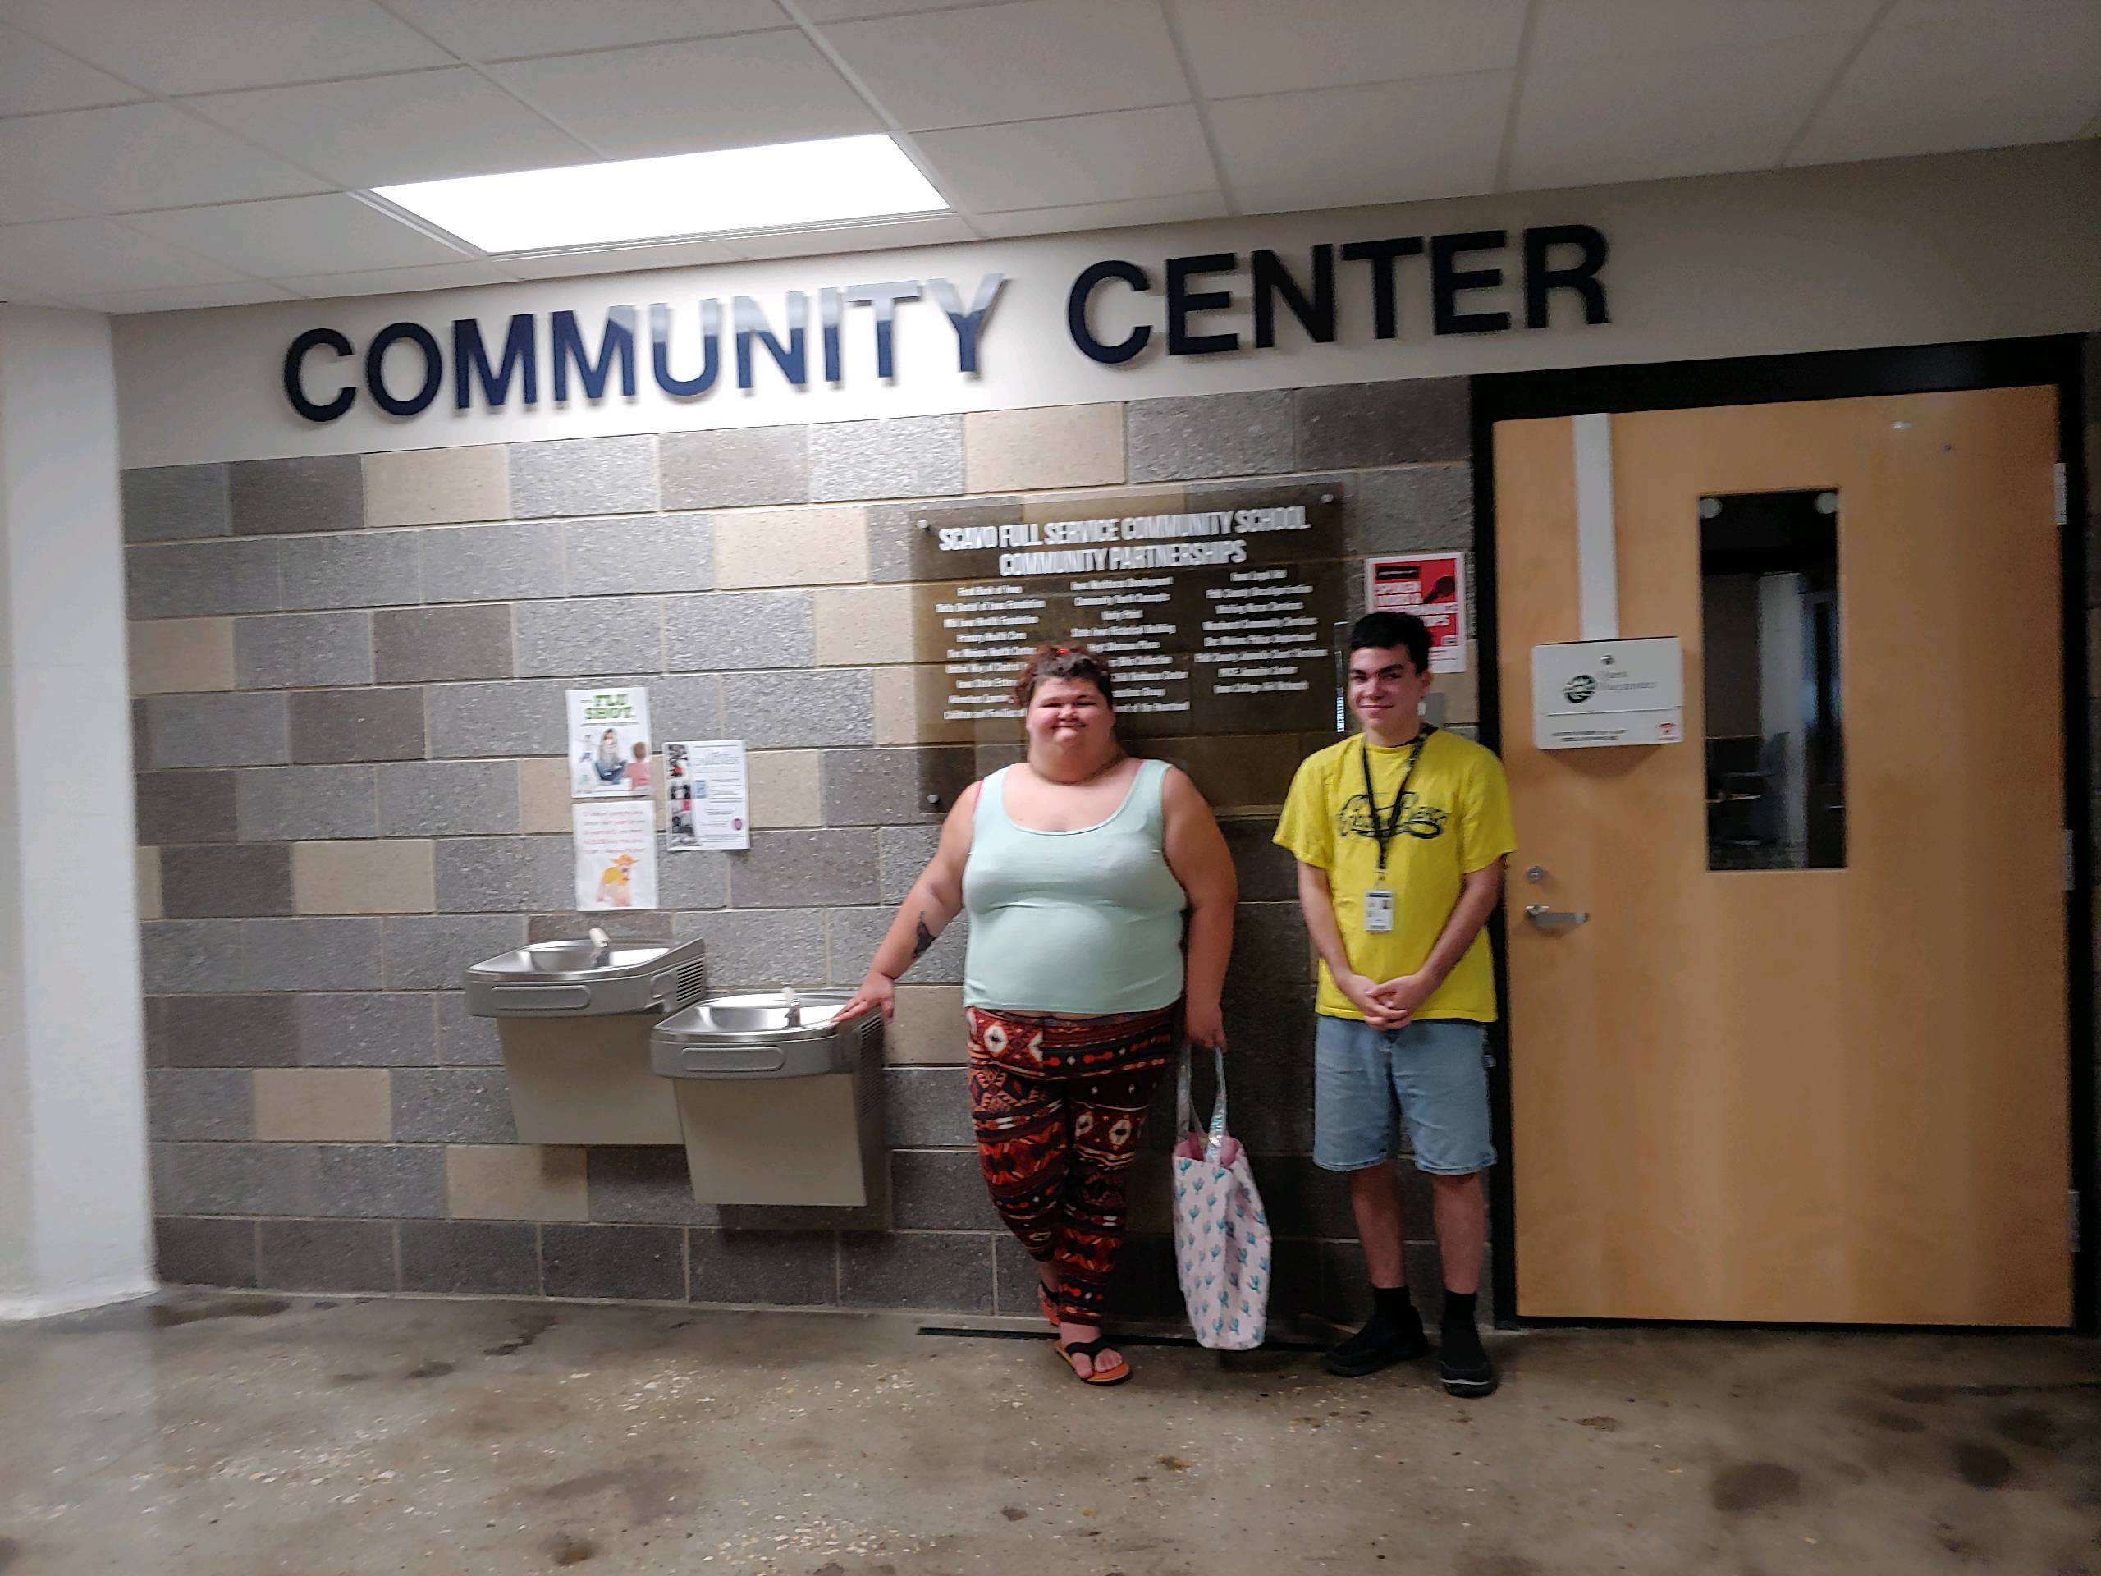
At the beginning of the month we took students upstairs to tour SCAVO’s Community Center. There are several services available to STEP students through the community center including a food pantry, medical clinic, dentist office, and mental health services. Any DMPS students is eligible to use the services and if they do not have insurance there so no charge. Appointments can be made for the medical and dental clinic by calling 242-8488. STEP staff can also assist students with scheduling and they can go to the community center during their STEP time. We have often used the medical services to assist students with work physicals and TB tests, but they can do almost anything a general clinic can do such as flu shots, family planning and birth control, and managing common illnesses.

To make an appointment at the medical or dental clinic, call: 242-8488.
Medical Clinic Hours: Monday and Thursday 9am-1 pm.
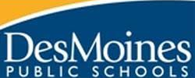
September Celebrations!
- Congratulations to Htoo for studying hard and getting her driving permit!
- Congratulations to Joe S. for getting a job at Dollar Tree.
- Congratulations to Chelsey for obtaining a job at Popeyes.

October Birthdays
Oct. 10th- Luke K.
Oct. 25th- Dean F.
Oct. 27th- Robbie F.
Oct. 29th- Chad W.
Oct. 31st- Chelsey M.
Secondary Transition Employment Program
Central Campus
1800 Grand Ave. Des Moines, Iowa 50309
515-242-7283
step@dmschools.org

