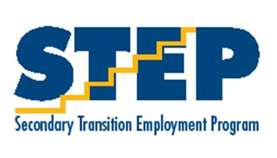
Off to a Great Start!
Upcoming Activities
Monday, September 2nd- Labor Day- No STEP Classes or Job Sites
Friday, September 7th- Select STEP Students to Autism Society of Iowa Employment Conference

Birthdays
Tuesday, September 4th- Katie Ellis
Sunday, September 9th- Mary Hilger
Monday, September 10th- Kitty Hedderich
Wednesday, September 12th- Devin Scott

  - August 2018

STEP Newsletter

STEP officially started back up on August 23rd with bus training and orientation for first year STEP students. On August 27th all students returned to STEP. We began the year by doing several ice breaker activities and we started our yearly assessments.
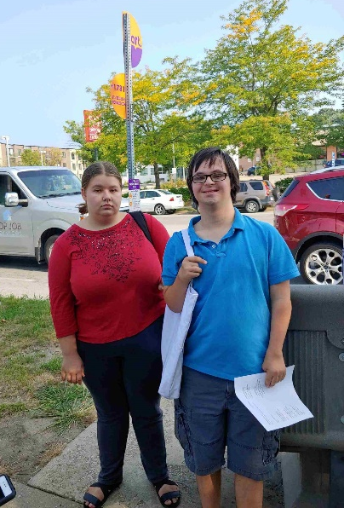
Amy, Dean, and Jami are all back as STEP teachers this year. Returning job coaches include Melissa Sarlat, Deanna Cole, Julie Grylls, Mary Hilger, and Lauren McCoy. We have a new job coach joining our team this year. Jenny Huisman transferred from Lincoln High where she worked in the library program. Jenny has
been off to a running start and has quickly learned the bus system and was already training students on the first day. We are excited to have her on the STEP team!
We are also supported this year by our DMPS consultant Jenny Ross and Vocational Rehabilitation Counselor Travis Taylor.

Tanzy and Ian K. bus training
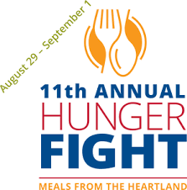

Meals from the heartland
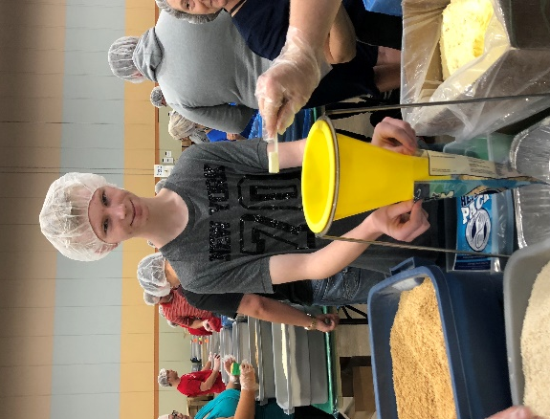
Service Learning

Throughout the year STEP students will have the opportunity to participate in various volunteer activities for STEP, Central Campus and our community. We encourage our students to take advantage of volunteer opportunities. Research has shown that job seekers that have volunteer experience are better prepared for the world of work and more likely to be hired compared to individuals that do not have volunteer experience.
The first of these opportunities was Meals from the Heartland. STEP students signed up go to Hy Vee Hall on Friday, August 31st to participate in the 11th annual Hunger Fight. Meals from the Heartland is a non-profit organization that packages meals for food insecure families in our city and around the world. STEP students prepared for the activity by looking at the Meals website and watching the training video. Once there, students worked in teams to complete various parts of packaging meals. It is always fun to see students work together to get a job done! We are very grateful to our students for donating their time and energy to help those in need!
If STEP students enjoyed this activity, Meals from the Heartland has ongoing opportunities for students to volunteer. Their volunteer needs are posted on their website. mealsfromtheheartland.org

transition curriculum
Service Learning

During the first few days of STEP students completed several transition assessments. These assessments help us get to know our students and plan for the year in STEP. Students completed STEP Student Interviews, the DMPS Transition Skills Checklist and the Transition to Work Inventory.
We are excited to be able to incorporate a new transition curriculum into STEP classes this year. This year we will be using a program called NEXT UP to guide our employment lessons. NEXT UP is a program that provides video lessons and accompanying lesson plans and activities for each weed during the school year. Lessons are customizable and adaptable to meet the needs of all of our students. It includes transition assessments to measure growth and social media platforms to engage students in our technological world.

Wednesday Skill Building Groups
Due to the district’s early dismissal schedule we do not have STEP class on Wednesday afternoons. We would like all students to come to morning class. On Wednesdays we provide group instruction in various independent living skills. This year we are starting with five groups which include DART training, consumer skills, cooking, technology, and a permit study group. STEP students were given a choice as to which groups they were most interested in to start with. Students will rotate to a new group every six weeks so they will have the opportunity to participate in each one.
Our first Skills Building Group will meet September 5th.

September NEXT UP Weekly Topics

Week 1: The Benefits of Working While in School
Week 2: Setting Employment and Personal Goals
Week 3: Identifying and Understanding Strengths and Weaknesses
Week 4: Creating an Employment Portfolio, Application, and Resume

2018 Autism Society’s Iowa Employment Conference

Friday, September 7th students that are interested will be attending the Autism Society’s 2018 Iowa Employment Conference. The conference will be held at the Sheraton in West Des Moines. We will leave from Central Campus around 8 am. Amy and Jami will drive students and stay with them during the conference. Since the conference goes until 3:15 we will also drive participating students home that afternoon. The conference is free, and lunch is provided.
We took several students to this conference last year and we thought it was very valuable. Students do not need to have an autism diagnosis to attend. We found the information to be relevant for all STEP students.
For more information about the conference go to http://events.r20.constantcontact.com/register/event?oeidk=a07efj9gm6pf21b1c96&llr=tapetldab
Conference Schedule
Speakers:
- Judith Warth
- Bronna Crase
- Laura Gibson
- Reyma McCoy McDeid
Conference Agenda
- 8:30am – Registration
- 9-10:30am – Who is in the Driver’s Seat – Judith Warth
- 10:30-10:45am – Break
- 10:45am - Noon – Panel of Employees with Autism – facilitated by Judith Warth
- Noon-1pm – Lunch provided
- 1-2pm – Developing Skills for the Job Interview – Laura Gibson & Reyma McCoy McDeid
- 2-2:15pm – Break
- 2:15-3:15pm – How to Create a Budget for Your Paycheck – Bronna Crase

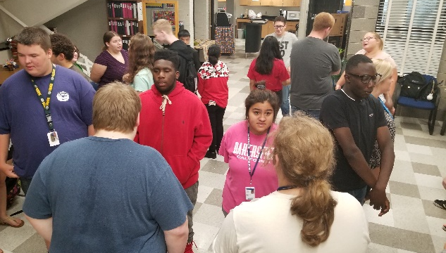
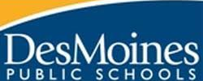
STEP students participate in an ice breaker activity called Concentric Circles
Secondary Transition Employment Program
Central Campus
1800 Grand Ave. Des Moines, Iowa 50309
515-242-7283
step@dmschools.org

